EE4053. Microwaves
Assignment 1 – Tear Down Report

Tear Down Analysis of a Software Defined Radio (HackRF One SDR)

Mehmet Akif Türkmenoğlu 150720061

Abstract — This report presents an in-depth teardown analysis of the HackRF One SDR, examining its design, internal components, and technological attributes.

INTRODUCTION

What is it?
It is a Software Defined Radio peripheral capable of transmission or reception of radio signals from 1 MHz to 6 GHz. Designed to enable test and development of modern and next generation radio technologies, HackRF One is an open source hardware platform that can be used as a USB peripheral or programmed for stand-alone operation [1].

Features
I want to give technical features so it will be meaningful which parts of the hardware do the correspondent work when I inform about hardware components [1];
- half-duplex transceiver
- operating freq: 1 MHz to 6 GHz
- supported sample rates: 2 Msps to 20 Msps (quadrature)
- resolution: 8 bits
- interface: High Speed USB (with USB Micro-B connector)
- power supply: USB bus power
- software-controlled antenna port power (max 50 mA at 3.0 to 3.3 V)
- SMA female antenna connector (50 ohms)
- SMA female clock input and output for synchronization
- convenient buttons for programming
- pin headers for expansion
- portable
- open source
Here is the physical view and the block diagram that shows each IC with their interior components.
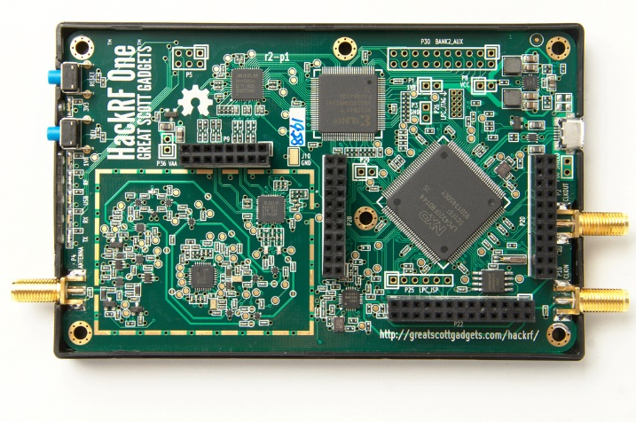
Figure 1. HackRF One
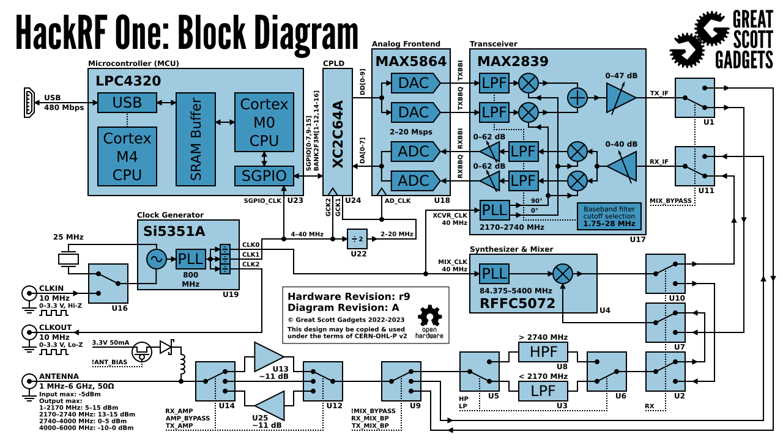
Figure 2. Block Diagram of the SDR

ANALYSIS

RF Modules (Radio Frequency Components)
MAX2839 (2.3 to 2.7 GHz Transceiver): A high-frequency transceiver responsible for signal reception and transmission, enabling HackRF One’s wireless communication capabilities [2].
MAX5864 (ADC/DAC): Functions as an Analog-to-Digital and Digital-to-Analog converter, allowing RF signals to be processed by digital systems [3].
RFFC5072 (Mixer/Synthesizer): A frequency mixer and synthesizer used to convert RF signals to different frequency ranges, ensuring the received signal is within a processable range [4].

Microcontroller and Processing Unit
LPC43XX (ARM Cortex-M4 Microcontroller): Acts as the control unit of HackRF One, managing processing power and overall system operation [1].

Timing and Clock Management
SI5351 (Clock Generator): Generates clock signals at different frequencies to synchronize and regulate HackRF One’s signal processing capabilities [1].

Storage and Memory
W25Q80BV (8M-bit Flash Memory): A flash memory chip used to store firmware and persistent data for HackRF One [5].

Buttons and LEDs
The Power LED indicates when the device is powered on, the Transmit (TX) LED lights up during RF signal transmission, the Receive (RX) LED signals active data reception, and the Status/Error LEDs help diagnose connectivity issues, signal processing activity, or communication errors.
The Reset Button restarts the microcontroller for troubleshooting or refreshing the system, while the Boot Mode Button enables DFU (Device Firmware Upgrade) mode for firmware updates or recovery [1].

SMA Connectors
HackRF One features SMA connectors for RF signal input and output, allowing external antennas to be attached. These connectors are located on the edges of the PCB, ensuring easy access for users to connect antennas or additional RF components.

Conclusıon
This teardown looks at HackRF One’s internal parts, main components, and design, showing its flexibility in software-defined radio (SDR). HackRF One is an open-source SDR that supports a wide frequency range, processes signals digitally, and has a simple but powerful design. It runs on USB power and can send and receive radio signals in real time.

References
- https://hackrf.readthedocs.io/en/latest/hackrf_one.html
- https://www.analog.com/media/en/technical-documentation/data-sheets/max2837.pdf
- https://www.analog.com/media/en/technical-documentation/data-sheets/MAX5864.pdf
- https://www.qorvo.com/products/p/RFFC5072

- https://www.winbond.com/resource-files/w25q80bv%20revk%2020151203.pdf

